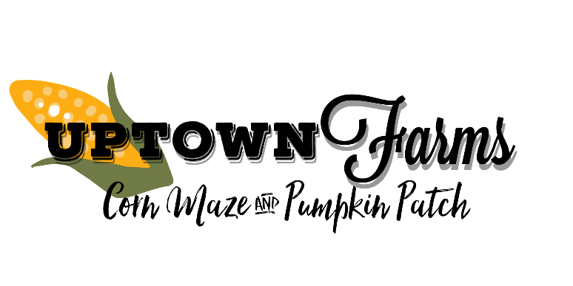

Pumpkin Fest at the Patch: Pumpkin Carving & Decorating Contest

Saturday, October 12, 2019
What?
Pumpkin Fest at the Patch is a contest for kids and adults as well as groups! Pumpkins will be entered into division by ages and judged to select a 1st, 2nd, and 3rd place winner in each age category. Winners will receive a fun prize!

When?
Pumpkins must be checked in Saturday, October 20 between 10 a.m. – 5:00 p.m. Judging will occur at 5:30 p.m. on Saturday, October 20. Pumpkins will remain on display until Sunday, October 21.
Divisions:
Ages 4 and Under
5-8
9-12
13-16
17 and Up
Group/Family Entries
Where?
Uptown Farms Corn Maze & Pumpkin Patch at 22225 Glade Road, Laclede, MO 64651.

Cost?
Free to enter! Visitors to the patch can access pumpkin display area and Country Store free of charge. Admission must be paid for access to corn maze, hay ride and other attractions.

How Do I enter?
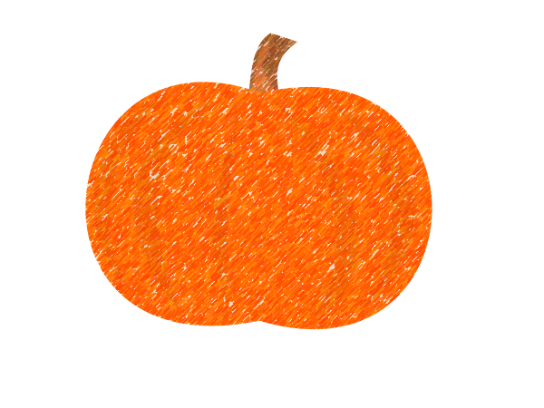
Simply bring your pumpkin or pumpkin display to Uptown Farms on Saturday, October 12, by 5:00 p.m. Entry to store and pumpkin display area is free of charge! You must leave your pumpkin on display through Sunday, October 13.

Rules:
Entries can be a single pumpkin or multiple pumpkins but must include at least one pumpkin in the display. Pumpkins can be carved, painted, or decorated however the contestant wishes. Pumpkins must be left until Sunday at 5:00p.m. Any pumpkins not picked up will be discarded.

